[1]

INTERNET OF THINGS (IOT) SECURITY MECHANISMS

First A. Author, *Fellow, IEEE*, Second B. Author, and Third C. Author, Jr., *Member, IEEE*

***Abstract*—** **Internet of Things (IoT) technology is prospering and entering every part of our lives, be it education, home, vehicles, or healthcare. The exchange of information between numerous items and network technologies is entailed by Internet of Things (IoT) notion. Today, everything should be interconnected via the internet is the vision of IoT. Since it opens new possibilities for new services, the IoT is and will continue to be the cornerstone for future development. All objects will be connected, and communication between them will be needed, although the CIA triad (at the very least) should not be jeopardized in any way. With the increase in the number of connected devices, several challenges are also coming up with IoT technology: heterogeneity, scalability, quality of service, security requirements, and many more. Security management takes a back seat in IoT because of cost, size, and power. It poses a significant risk as lack of security makes users skeptical towards using IoT devices. This, in turn, makes IoT vulnerable to security attacks, ultimately causing enormous financial and reputational losses. It makes up for an urgent need to assess present security risks and discuss the upcoming challenges to be ready to face the same. Implementing security measures, such as encryption, authentication, access control, network security and application security, for IoT devices and their inherent vulnerabilities is ineffective. Therefore, existing security methods should be enhanced to secure the IoT ecosystem effectively.**

***Index Terms*—IoT, Blockchain, AI, Intrusion Detection**

# I. INTRODUCTION

I

n the ICT sector for quite some time the term Internet of Things (IoT) has been used. In 1982 a vending machine was connected through ARPANET by four Carnegie Mellon University students (Ivor Durham, John Zsarnay, David Nichols, and Mike Kazar) to remotely check in each dispensing column the availability of the soda cans and their coolness. In 1999 during a presentation at Proctor & Gamble [1] it was addressed by Kevin Ashton regarding recently introduced Radio Frequency Identification (RFID) technology importance in the industry of supply chain. The need has grown over the internet for integration of all things since then. A market value of approximately $3 billion in 2020 with 20 billion devices in number will be reached according to major consulting firms. The size and power needed to perform a computation is almost half every two years and computation power is doubled at the same time is the reason for boom in IoT sector. For a wider range of applications more powerful and smaller devices are accessible for interconnection and data sharing. The issues in terms of standardization on low-energy & low-power devices and interoperability between different stacks, are due to IoT devices wide range of disciplines and technologies. Questions about how to assure confidentiality, integrity, and availability while considering these factors together, new security difficulties appear. All revolutionary developments, including IoT, provide people with a better life today and in the future, but there is a significant security problem. The public is increasingly concerned about privacy, especially today. The security of the IoT must be improved for it to pervade day to day lives of people.

Since IoT is a new technology, its security is critical to the growth of the IoT business. A major obstacle in the development of IoT is the lack of comprehensive and established security standards and models. The IoT in comparison to traditional networks, integrates a variety of networks, including Wireless Sensor Networks, RFID systems, mobile vehicle networks, 3G/4G/5G technologies, PANs, VPNs, WiMAX, and so on. The security challenges must be addressed which become more complex than any other network system now in use as the IoT environment gets more demanding and complicated. The motivation for pursuing IoT research stems from a lack of long-term and flexible solutions to some of the most pressing security concerns. Some early security methods and solutions are currently in place, which needs improvement and standardization. The entire potential of IoT is extending towards a user inclusive IoT and beyond enterprise centric solutions, in which user-contributed information and IoT devices flows are encouraged. This will enable a new set of high-value services for society and new user-centric IoT information flows. Security is one of the most significant challenge to IoT nowadays. Which protocol stack delivers the best security and privacy services is a key concern. Because security can be supplied at many levels, deciding the best choice is not an easy task. Because the IoT is still a new idea, many organizations and people in the industry are unaware of it. Because of their lack of awareness, they may be fearful of, or completely uninformed of, the possible security and privacy risks associated with their IoT deployment. As a result related to IoT security, many businesses are interested in learning more about the benefits, drawbacks, potential threats, solutions and problems. In conjunction with their IoT rollout, achieving cost-effective security they also require understanding of what level is needed of information security ability. This ability and knowledge should aid in non-IoT to an IoT firm transition, as it will allow both employees and management to understand and solve their issues and uncertainties about their investments and potential security risks. Managers can do a balanced risk-benefit analysis of IoT adoption for a given application or family of applications in this manner.

Living in an era where (IoT) covers a lot of aspects in modern human life and how cyber-attacks will lead the security issues related to (IoT) if not applying the proper solutions to prevent any damage and exposure to individuals privacy. Surrounded by a lot of security challenges, (IoT) is made of multiple technologies where its devices come from a lot of different technology back grounds, the security fundamentals and properties of each thing is made of, are different than each other, which makes it hard to find a common ground to get them all together, in addition, multiple verticals, scalability, big data, availability, resource limitation, remote locations, mobility and delay sensitive services are other security issues that lead us to say that traditional internet security mechanisms are not always feasible or appropriate to adopt, with that said, these weak security measures enable attackers to target (IoT) devices. (IoT) networks and systems remain very vulnerable and require stronger protection mechanisms.

An Intrusion Detection System (IDS) is a security network aspect that detects networks and systems for malicious activities or policy breaches. Recently IDS are gaining a lot of popularity and attention from security specialists to protect (IoT) devices along with hybrid approaches, that combine two or several IDS methods. In this paper, we propose a hybrid IDS method based on detecting a potential DoS attack by classifying the traffic behavior and combining the advantages and overcoming the disadvantages of both the signature and anomaly based IDSs. The paper introduces some of the related work on hybrid methods and IoT-DoS in last years, also compares the difference between both (signature and anomaly) methodologies, discussing the data flow of the logic behind this approach along with the results gained from the designed framework simulation of this hybrid combination.

# II. Information Security

## A. Historical background

Information security processes and techniques are as old as the information each self. From the very first years of communication, the value of security mechanisms was very well comprehended. In 50 B.C., Julius Caesar was one of the first to use these practices by inventing the Caesar’s cipher to get his information scribbled if it were found in unwanted hands. From 16th century mid various administrations around the globe, created organizations to secure the information and communication (e.g., In 1653 Deciphering Branch and UK Secret Office). More recently, during 19th century and because of the two World Wars many authorities were created to protect the privacy of information; exchange of war related information between allies of the World War II, brought into the picture the necessity of encrypting the information to become unreadable. This brought us to the Enigma Machine [2], which was invented at the end of WWI by Arthur Scherbius, but Nazis implemented before and throughout the WWII for warfare related data encryption. Alan Turing successfully decrypted Enigma.

By 20th century’s end and 21st century’s early years, while data encryption is taking place, there had been rapid advancement in telecommunications, hardware, and software. Things are getting smaller and smaller, more powerful, and even cheaper, bringing computing closer to everyone, appealing not only to businesses but to individuals as well. The Internet expansion and availability also helped on all these objects to be interconnected and made information publicly available.

The rapid growth of electronic business was used even for criminal acts, stimulated the need for protecting computers, networks and information.

## B. Information Security Definition

It is a diverse field of closely linked research and professional goals to the implementation and development of all types of security countermeasures (legal, human-oriented, organizational, and technical) in order to keep all of its areas data (inside or around the establishment's boundary) and consequently, data management free of malicious attacks where it is created, processed, stored, communicated, and demolished [3].

Confidentiality, Integrity, and Availability of relevant data and IT paradigms are three main pillars of information security, that ensure following goals:

1. Only authorized parties have access to information (Confidentiality),
2. No unapproved modification in the information (Integrity),
3. Whenever authorized persons demand information it can be accessed (Availability).

## C. The CIA (Confidentiality, Integrity, and Availability) Model

For describing the model, the term used is the CIA trio. Inside an organization for information security policy guidance, the CIA triad is the method used. In security these three are regarded as the most important aspects/ pillars.

1. **Confidentiality**

Privacy and Confidentiality are synonymous. It ensures that right ones only have access to the critical data and is out of the hands of the wrong people. Only authorized persons are granted accessibility to the data.

Passwords and Usernames, soft tokens, hardware, security tokens, biometrics & two-factor authentication and other procedures used to keep confidentiality include, but are not limited to, data encryption.

1. **Integrity**

Throughout data life cycle consistency, correctness, and dependability are referred to as Integrity. To change the data, authorized persons/ parties are only allowed.

For preventing authorized users to do accidental deletion or mistaken changes, user access controls and file authorizations may be used, which is also a problem; for integrity verification checksums (cryptographic checksums) must be available; in case of permanent loss to restore the data to its actual state backups must be available.

1. **Availability**

Availability means that the service has always been present, that proper bandwidth is available, that network bottlenecks are avoided, and that redundancy and disaster recovery are in place to assure system availability. Proxy servers, Intrusion Detection Systems (IDS), and firewalls can be employed to keep intruders out and backup copies should be kept somewhere else other than inside the primary data storage.

Realization that the usual methods of storing data and transmitting are extended by Data Protection Act's requirements is vital. The security measures for personal data collection, storage, and processing are set up by seventh data protection guideline.

As a result, the preventive controls you implement should ensure following:

1. Destruction, alteration, access, and visibility of personal data is only done by authorized people.
2. Authority can only be exercised by those people within the scope.
3. Personal information can be recovered if it is accidentally lost, altered, or destroyed, preventing any harm or discomfort to the relevant parties.

Following must be ensured by the organizations:

* 1. For ensuring data protection, relevant technical and physical security protocols must be employed.
  2. Security breaches must be dealt with pertinent practices.
  3. From the start of developing new applications, privacy and security must be considered.
  4. Internal and external data sharing must be tracked.
  5. Policies for ensuring data recovery through backups must be in place.

There are so many threads that need to be considered when coping with Information security. In Table 1, most important IoT security threats are summarized.

TABLE I

IoT security threats

|  |  |
| --- | --- |
| **Security issue** | **Details** |
| **Web interface weaknesses** | * Default Easily Guessable Credentials * Account Record * Credentials are Exposed in Network Traffic (XSS) * Session Management * SQL Injections * Account Lockout Settings that are not as good as they should be * Cross-site Scripting |
| **Insecure Network** | * Services at Risk * Overflow of the Buffer * DoS * Open Ports via UPnP * DoS via Network Device Fuzzing * UDP Services that can be exploited |
| **Insufficient Authentication/ Authorization** | * Inadequate password complexity * Credentials that aren't properly protected * Two-factor authentication is inadequate * Risky password recovery * Privilege escalation * There is no role-based access control. |
| **Lack of Transport Encryption** | * Internet Services That Aren't Encrypted * Unencrypted Local Network Services * SSL/TLS implementation flaws * SSL/TLS configuration error. |
| **Insecure Cloud Interface** | * Account Counting * There was no account lockout * Credentials discovered in network traffic |
| **Privacy Concerns** | * More data than is needed for functionality is gathered. * Gathered sensitive information * The data is not anonymized. * Data collection without encryption * Unsecured personal information * Unauthorized access to personal data * There were no retention policies implemented. |
| **Insecure Mobile Interface** | * In Network Traffic Credentials are Exposed * Account Enumeration * No Account Lockout |
| **Security Configurability Insufficient** | * Absence of * Options of Password Security * Granular Permission Model * Logging security * Monitoring security |
| **Physical Security Poor** | * USB Ports available on devices * Storage Media available on devices |
| **Insecure Software/ Firmware** | * Undated devices * Updates to unencrypted files * Transmissions of unencrypted connections * Ensure that the update file does not have any sensitive information. * Updates that are unsigned and unverified |

TABLE II

Extended CIA model

|  |  |
| --- | --- |
| **Requirement** | **Details** |
| **Authenticity** | * Just authorized persons could have access to the system or sensitive information. |
| **Authorization** | * The rights and protections of device services and tools should be restricted so that they can only access the resources needed to complete their assigned tasks. |
| **Confidentiality** | * Intruders should be kept out of information transmission between nodes. |
| **Integrity** | * It is not permissible to tamper with related information. |
| **Availability and**  **Continuity** | * To prevent command and control failures and interruptions, security service availability and continuity must be guaranteed. |

## D. Security elements

For the security domains, it is important to find key elements for the information security (Fig 1). In the following sections, the key elements definitions are described.

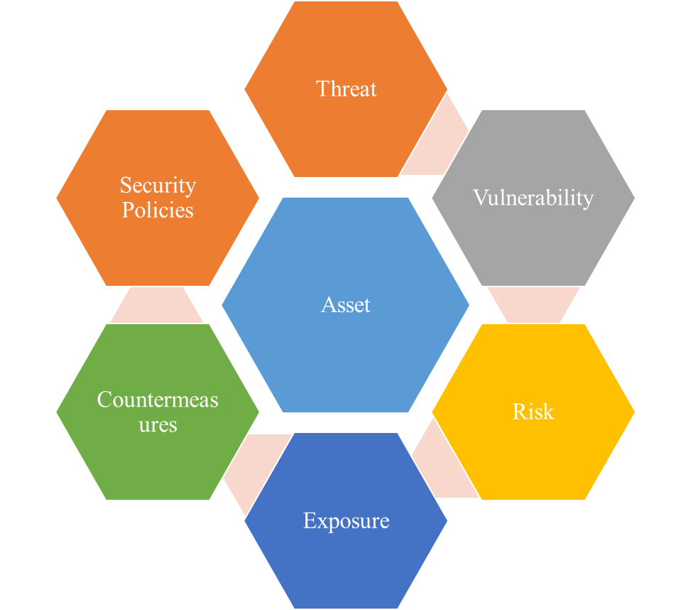

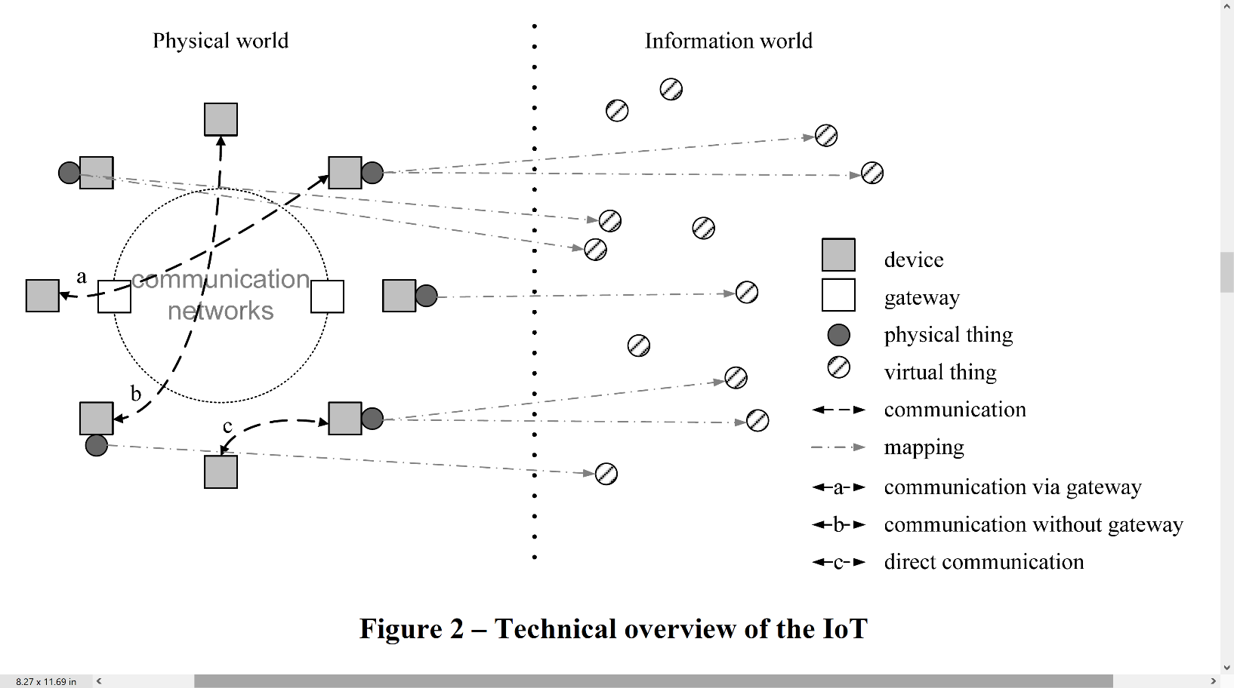

**Fig 1.** Technical overview of the IoT [4].

**Fig 2**. Security elements.

1. **Asset**

Asset is any datum, device, or in general any module of the organization’s universe that supports information-driven processes. Assets can include hardware, software, and information as well. Assets should be always protected under the CIA triad framework.

1. **Threat**

In computer security, a threat is anything that can make a damage. A danger is something that could happen, or not. Dangers can prompt assaults on computer systems and that is only the beginning.

1. **Vulnerability**

A vulnerability is any flaw or gap in safety strategies that can be manipulated by attacks to gain unauthorized access to an asset.

1. **Risk**

When a treat threat is exploiting a vulnerability then a risk may be found, the possibility for loss, damage, or destruction of an asset.

1. **Exposure**

A situation in a computing system (or combination of systems) that is not a general risk but enables an adversary to get information or hide operations.

1. **Countermeasures**

Countermeasure shows any action, device, process, or technique that potentially may lead to reduce threats, vulnerabilities, or any attacks by preventing it or minimizing the damage. Corrective actions need to be taken even if it decided to simply mitigate the risk.

1. **Security Policies**

Security Policy refers to the set of rules adopted by an organization to ensure that IT and network infrastructure adhere to data security principles, and that users take all proper precautions when contacting any arrangement of business action outside or inside of the organization's borders by ensuring that the CIA triad is respected.

TABLE III

For each IoT protocol layer, different threats and risks are presented

|  |  |
| --- | --- |
| **Layer** | **Risks** |
| **Perception** | Spoofing, signal jamming, outage, eavesdropping |
| **Network** | Wormhole, sending, man in the middle, floods |
| **Support** | DoS, unauthorized access, data tampering |
| **Application** | Sniffers/loggers, DDoS, social and session hijacking, injections |

# III. IOT

## A. Background

Kevin Ashton was the first person to use the term in 1999 [1], defining it as "Inside Internet-like framework their virtual representations and unique identification of things." From a technological standpoint, an infinite number of globally linked things network is the IoT – actuators, sensors or devices - which supply numerous facilities over the Internet. Fundamentally, IoT refers to a move from reactive to proactive systems, from delayed problem management to automated sense-and-respond capabilities.

Authors refers the IoT in [4] as "a digital society’s worldwide network that enables improved facilities by linking things (virtual and physical) using emerging & current compatible communication and information platforms."

IoT consists of two key elements: "internet" and "things" [5]. Communication allows things to coordinate their actions and reach decisions together it allows them to hear, see, think, compute, and act. The technology gives things making authoritative decisions that help various applications using intelligence and consensus. From the standpoint of passive observers, they transform objects or sensors into active members of a computing system, communicating, working collaboratively, and making critical decisions. As a result, they present challenges that require specialized communication standards [6].

Communication is the most important aspect in achieving IoT. No matter how smart or capable the devices are, if they cannot send and communicate then they cannot be a part of the IoT ecosystem. The actual physical and link layer communication inside the IoT may be achieved in a variety of methods, therefore how this communication is carried out is less critical.

Through a communication channel, physical components can interact:

* CCTV cameras that check a location, for example, can be accessed through a gateway.
* If there is not a gateway, directly, for example, two smart home gadgets that are near to one another can communicate via Bluetooth or ZigBee protocols.

By using virtual objects, the projection into the digital environment of physical objects can be done, and the relationship between virtual objects & actual objects may not be necessary. A physical object can have many virtual identities; therefore, it may run numerous services.



**Fig 3.** IoT Roadmap [7].

## B. Fundamental characteristics

1. **Interconnectivity**

The worldwide communication and information exchange architecture allows anything to be interconnected.

1. **Scalability**

The amount of devices currently linked to the internet will be at least an order of magnitude lesser than the amount of gadgets interact with one another and required to be controlled. The proportion of gadget communication to human-triggered communication will noticeably shift in favor of device-triggered communication. The collection and interpretation of information is crucial for application purposes, which is linked with efficient management and semantics of data.

1. **Dynamic changes**

Dynamic alteration of device states (such as sleeping & waking up, being connected & offline and location & speed). Furthermore, fluctuation in the number of devices can also happen.

1. **Heterogeneity**

The IoT devices are based on many networks and physical platforms which makes them diverse. Communication with other service platforms or devices is done through various networks

1. **Things related services**

IoT can deliver thing-related services under the restrictions of things, such as lexical uniformity and data security between virtual & real things and will alter both digital and physical world technologies.

## C. IoT Roadmap

It is widely accepted that RFIDs were the ancestors of IoT. Originally used in supply chain industry for tracking purposes, very rapidly moved to the market such as food safety, transportation, surveillance, security, and others facilitated by the network evolution as elaborated in Fig 3. These days is used for monitoring and controlling of remote or distant objects [7].

A significant increase is predicted in the total installed IoT devices and is estimated to increase from the 13.8 billion units estimated in 2021 to 30.9 billion units in 2025 [8].

TABLE IV

IoT attacks

|  |  |
| --- | --- |
| **Attacks** | **Risks** |
| **Signal/Radio Jamming** | Integrity and availability |
| **Spoofing** | Confidentiality, integrity, and authenticity |
| **Node Outage** | Authenticity and availability |
| **Path-based DoS Attack** | Authenticity and availability |
| **Eavesdropping** | Confidentiality |
| **Device-tampering/Node capturing** | Confidentiality, integrity, authenticity, and availability |

# IV. Security in IoT

## A. Introduction

In terms of hardware, software, and network many techniques to support the supplied services are required for IoT network implementation. Many complications occur as far as security of an IoT ecosystem is concerned, which must be addressed.

* 1. The greatest barrier, whether virtual or real, are things themselves in the IoT environment. Number of difficulties in IoT network is directly proportional to the number of devices linked. Creation of as many items as conceivable is the basis of IoT. Ten years ago, we simply needed to safeguard our PC to access the internet; now, we must protect PCs, Smartphones, smart gadgets, cars, wearables, and everything else that is linked to the internet.
  2. The greater the number of gadgets, the more difficult it is to manage them. Firmware and operating system upgrades are critical for supporting elevated levels of security. Even consumers may find it challenging to keep tens of devices up to date with the newest security updates.
  3. Irrespective of the amount of IoT devices the transmission of information and communication, the information gathered for processing must be delivered to the next step. Including encryption, preservation of privacy and identification should be crucial elements in security of IoT.
  4. Smart gadgets unauthorized use.
  5. To the public, unprotected gadgets were sold by the vendors who did not care about security and even few years ago, overlooked security for certain devices.
  6. Inadequate experience and skills may serve as a backdoor to security vulnerabilities. When the milk is done, a typical customer can be notified by the smart is a considerable move ahead; however, it can be hacked, and if not properly secured same network devices can access its data.

For overcoming said problems, multiple implementation possibilities extending through famous globally used protocols (HTTP, TCP, SMTP) or copyrighted IoT protocols (ZWave and ZigBee) as well as open standards (from W3C, IEEE, or IETF) for standardized protocols (CoAP or 6LowPAN).

A set of several studies were considered to stipulate the following summarization for security requirements, challenges, threats, and potential solutions ( [9], [10], [11], [12], [13], [14]).

TABLE V

Cryptographic Algorithms frequently used

|  |  |  |
| --- | --- | --- |
| **Used Process** | **Type** | **Objective** |
| SHA-1/ SHA-256 | Hashing | Integrity |
| DH | Asymmetric Key Agreement | Key Agreement |
| * ECC * RSA | Encryption (Asymmetric) | * Digital Signatures * Key Transport |
| AES | Encryption (Symmetric) | Confidentiality |

## B. IoT Protocols associated to Security

The most relevant significant IoT standards have been chosen to be assessed for security purposes. Every one of these protocols are components of the application or transport levels of the IoT protocol stack.

1. **Datagram Transport Layer Security (DTLS)**

Datagram security is ensured by DTLS protocol. TLS based protocol is built to supply similar security.

Even though security was kept in mind while creating. In 2013 by using OpenSSL implementation of DTLS the plaintext was extracted from DTLS while encryption was done using Cipher Block Chaining mode, by scientists of Royal Holloway, University of London.

1. **Quick UDP Internet Connections (QUIC)**

Between two destinations composite connections are collectively supplied by employing QUIC protocol that uses the User Datagram Protocol (UDP). Lowering transport latency and the number of connections capability, Secure Socket Layer (SSL) & Transport Layer Security (TLS) like security protection may be supplied. To prevent congestion issues in both directions’ bandwidth estimation can be done using QUIC.

TABLE VI

Security protocols assessment

|  |  |  |  |  |  |  |
| --- | --- | --- | --- | --- | --- | --- |
| **Features** | **Layer** | **Objective** | **UDP** | **Delivery** | **Inter-operability** | **Security** |
| **QUIC** | Transport | Composite connections | Yes | Not guaranteed | Yes | Yes |
| **DTLS** | Transport | Communic-ation privacy for UDP | Yes | Not guaranteed | Partial | Yes |

1. **Constrained Application Protocol (CoAP)**

RFC 7228 defines the CoAP which has been enhanced by RFC 7252 for applications of IoT. CoAP is meant to allow communication with each other among different devices on a restricted network and among gadgets on the internet having multiple constrained networks. For SMS, CoAP is used over cellular networks.

With HTTP, CoAP is expected to be used in conjunction for web integration, to supply multicast, and to supply minimal overhead and simplicity, having significant importance in IoT. Devices that support protocols like UDP, CoAP can be used.

1. **Message Queuing Telemetry Transport (MQTT)**

To take into consideration unreliable networks, high latency and low bandwidth, in 1999 the specifically suited IoT Machine to Machine (M2M) light weighted messaging protocol was invented by Arlen Nipper and Andy Stanford-Clark. Message delivery assurance and dependability were the main criteria while implementing the protocol. Therefore, for environments like M2M in IoT, this protocol is excellent. In later versions SSL is used for encrypting the login information passed by the users to devices.

The subscriber/ publisher mode is the basis of working model of MQTT (see Fig 4) this means that a publisher uses a broker to made available a set of information, which is made accessible to others who are ready to take part in it (subscribers).



**Fig 4.** MQTT working model.

1. **JavaScript Object Notation (JSON)**

In 2000 JSON was introduced by Douglas Crockford, as described in RFC 7159. To communicate array data types and attribute value pairs of data objects human readable text is employed by JSON. It is widely used asynchronous communication protocol that is language independent. Though it was designed using JavaScript, wide range programming languages supports JSON format data structures.

1. **Concise Binary Object Representation (CBOR)**

As defined by RFC 7049, it is a binary data format built on JSON, resulting in small packet sizes. The CoAP IoT protocol makes use of it.

# V. IoT Security Threats

IoT integrates the Internet with the physical world to provide an intelligent interaction between the physical world and its surroundings. Generally, IoT devices work in diverse surroundings to accomplish different goals. However, their operation must meet a comprehensive security requirement in cyber and physical states [15], [16], [17]. IoT systems are complex and contain multidisciplinary arrangements. Therefore, maintaining the security requirement with the wide-scale attack surface of the IoT system is challenging. To satisfy the desired security requirement, the solution should include holistic considerations. However, IoT devices mostly work in an unattended environment. Consequently, an intruder may physically access these devices. IoT devices are normally connected over wireless networks where an intruder might expose private information from the communication channel by eavesdropping. IoT devices cannot support complex security structures because of their limited computation and power resources [18]. Therefore, securing the IoT system is a complex and challenging task. Given that the main objective of the IoT system is to be accessed by anyone, anywhere and anytime, attack vectors or surfaces also become accessible to attackers [19], [20]. Consequently, causing potential threats to become more probable. A threat is an act that can exploit security weaknesses in a system and exerts a negative impact on it [18]. Numerous threats, such as passive attacks (e.g. eavesdropping) and active threats (e.g. spoofing, Sybil, man-in-the-middle, malicious inputs and denial of service (DoS)), might affect the IoT system. Fig 5 shows the potential attacks that can affect the main security requirements (authentication, integrity nonrepudiation, confidentiality availability and authorization).

The following main security properties should be considered while developing an effective IoT security method.

**Confidentiality**: Confidentiality is a vital security characteristic of IoT systems. IoT devices may store and transfer sensitive information that should not be revealed by unauthorised individuals. Medical (patient related), personal, industry and military data are highly confidential and must be secured against unauthorised access [18], [21]. However, in specific scenarios, such as IoT medical devices, although communications are encrypted and data are confidentially stored and transferred, attackers can still sense the existence of the physical device and can even track the holder. In such a situation, the location confidentiality of the holder is exposed and put at risk [22].

**Integrity:** Data from IoT devices are generally transferred through wireless communication and must be changed only by authorised entities. Integrity features are thus fundamental in ensuring an effective checking mechanism to detect any modification during communication over an insecure wireless network. Integrity features can secure the IoT system from malicious inputs that might be used to launch structured query language (SQL) injection attacks [23]. A deficiency in integrity inspection can allow for modification of the data stored on the memory of IoT devices, which can affect the main operational functions of the physical devices for a long time without being detected easily. IoT systems have various integrity requirements. For example, IoT implantable medical devices require effective integrity checking against random errors because they affect human lives directly. Loss, errors or modification of information in several circumstances can lead to loss of human lives [22], [24], [25].



**Fig 5.** Potential threats in the IoT system

**Authentication:** The identity of entities should be perfectly established prior to performing any other process. However, due to the nature of IoT systems, authentication requirements differ from system to system. For example, authentication should be robust in an IoT system where a service needs to offer robust security rather than high flexibility. Trade-offs are a major challenge in developing an effective authentication scheme. For example, the trade-off between security and safety in IoT medical devices is that both security and safety must be balanced when designing an authentication scheme. Similarly, the trade-off can be between an effective authentication scheme and battery-based devices or between privacy and security [26]. Therefore, an IoT system requires an effective authentication that can balance system constraints and provide robust security mechanisms [27].

**Authorization:** Authorization includes granting users access rights to an IoT system, such as a physical sensor device. The users may be machines, humans, or services. For example, the data collected by sensors should only be delivered to and accessed by authorized users (authorized objects and service requesters) [28], [29]. In other words, an action must be performed only if the requester has satisfactory authorization to command it. The main challenge in authorization in IoT environments is how to grant access successfully in an environment where not only humans but also physical sensors (things) should be authorised to interact with the IoT system [30]. In addition, in handling huge amounts of data in such a heterogeneous environment, the data must be protected throughout the sensing and transmission process and should be made available only to authorised parties [31].

**Availability:** The services delivered by IoT systems must always be available to authorised entities. Availability is a fundamental feature of a successful deployment of IoT systems. However, IoT systems and devices can still be rendered unavailable by many threats, such as DoS or active jamming. Therefore, ensuring the continuous availability of IoT services to users is a critical property of IoT security.

**Non-repudiation:** The non-repudiation property is meant to provide access logs that serve as evidence in situations where users or objects cannot repudiate an action. Generally, nonrepudiation is not considered a key security property for many IoT systems [18]. However, non-repudiation can be an important security property in specific contexts, such as payment systems where both parties cannot repudiate a payment transaction [18]. For an effective IoT security scheme, the security properties above should be considered. However, these properties can be exploited by several security threats, as shown in Fig 5. In the following subsection, we briefly discuss potential security threats to understand how different security properties should be maintained in a secure IoT environment.

## A. Threats in IoT

Security threats can be categorized as cyber and physical. Cyber threats can be further classified as passive or active. The following subsection provides a brief discussion of these threats.

1. **Cyber Threats**
2. **Passive threats**

A passive threat is performed only by eavesdropping through communication channels or the network. By eavesdropping, an attacker can collect information from sensors, track the sensor holders, or both. Currently, collecting valuable personal information, particularly personal health data, has become rampant on the black market [17]. The value of personal health information on the black market is $50 compared with $1.50 for credit card information and $3 for a social security number [17]. Moreover, an attacker can eavesdrop on communication channels to track the location of the IoT device holder if its communication channel is within range [32], [33], thus causing a violation of privacy.

1. **Active threats**

In active threats, the attacker is not only skilful in eavesdropping on communication channels, but also in modifying IoT systems to change configurations, control communication, deny services and so on. Attacks may include a sequence of interventions, disruptions and modifications. For example, potential attacks on an IoT system (shown in Fig 5) may involve the following active attacks: impersonation (e.g. spoofing, Sybil and man-in-the-middle), malicious inputs, data tampering and DoS. An impersonation attack is intended to impersonate an IoT device or authorised users. If an attack path exists, active intruders can attempt to partially or fully impersonate an IoT entity [19]. Malicious input attacks are intended to insert malicious software into the targeted IoT system. This software will run a code injection attack. The injected malicious software has a dynamic nature, and new types of attacks are constantly introduced to violate IoT components remarkably because IoT systems have a naturally large, well-connected surface [34], [35]. Meanwhile, data tampering is the act of intentionally changing (deleting, changing, manipulating or editing) information via unauthorised operations. Data are commonly transmitted or stored. In both situations, data might be captured and tampered, which might affect the significant functions of IoT systems, such as changing the billing price in the case of an IoT-based smart grid [36]. Many types of DoS attacks can be utilized against IoT. These types range from conventional Internet DoS attacks that are established to deplete the resources of the service provider and network bandwidth to signal jamming that targets wireless communication. Distributed DoS (DDoS) is a severe DoS where several attacks are launched with different IPs, which makes discriminating it from normal traffic of normal devices challenging compared with the attack with a huge traffic form signal or limited number of devices that is easier to discriminate from normal traffic and devices. Although different forms of DoS attacks exist, they have a common aim: to interfere with the availability of IoT services [37]. IoT systems have billions of connected devices that can be exploited through destructive DDoS, such as Mirai. Mirai is an exceptional type of botnets that has recently caused largescale DDoS attacks by using IoT devices [38], [39].

1. **Physical threats**

Physical threats can be in terms of physical destruction. In these threats, the attacker generally does not have technical capabilities to conduct a cyber-attack. Therefore, the attacker can only affect the reachable physical objects and other components of IoT that lead to terminating the service. By adopting IoT systems, these types of attacks may become widescale because most of the physical objects of IoT (sensors and cameras) are expected to be everywhere and physically accessible [19], [40]. Physical threats may also be caused by unintended damage from natural disasters, such as floods or earthquakes, or disasters caused by humans, such as wars [15], [16].

## B. Attack Surfaces

In this section, we discuss possible IoT system attack surfaces and the potential threats related to each surface. As shown in Fig 6, IoT attack surfaces can be categorised into physical device, network service, cloud service, web and application interface. The new IoT environment introduces threat surfaces.



**Fig 6**. IoT attack surfaces

1. **Physical Device Surface**

Physical devices, such as RFID, are a main part of IoT systems. In an embedded communication system, RFID plays a significant role in implementing microprocessors for wireless communication [41]. The key characteristic of RFID tags is automatic identification through a unique identifier that involves fast information transmission between tags (RFID is tagged to an object that can be anything, from human to animal) and readers [42]. The main function of RFID technology is to supervise the process of objects in real time; this bridges the interaction between virtual and actual worlds. Consequently, these tiny physical devices can be expended in an exceptionally wide range of applications [41]. However, most physical devices suffer from many security-related issues. Another unit of physical device surface is the sensor node. Sensor nodes mainly consist of sensors used for sensing and actuators used for actuating devices in accordance with specified instructions. Sensors nodes commonly have high latency.

Most physical devices are resource-constrained and contain valuable information, which makes them a potential surface for attackers; for example, they can be exploited to track their holders, flooding them with many access requests that cause DoS or other attacks, such as eavesdropping, spoofing and counterfeiting [43], [44]. Moreover, this surface is highly vulnerable to physical threats because it is the most physically accessible surface for an attacker.

1. **Network Service Surface**

The IoT system contains physical objects (sensors and actuators) that are connected through wired and wireless technologies. Sensor networks (SNs) are significant resources for realising IoT systems. SNs can be constructed without an IoT system. However, an IoT system cannot be constructed without SNs [45], [46]. An IoT system consists of SNs and a wired network, thus creating a large-scale network surface. Such a wide network surface can be potentially vulnerable. Moreover, IoT systems face new security threats that are inherited from wired and wireless SNs. These new threats are introduced when traditional networks are directly integrated into IoT networks. The direct integration of a wireless SN into an IoT network poses several issues because traditional networks are no longer secure within IoT environments; for example, the resilience of WSNs (the sensors within a WSN openly provide its information to external parties) makes this network completely vulnerable to attacks in IoT environments [45], [46].

Other threats can be designed by attackers to target the routing protocol that may lead to network failure. Accordingly, designing a secure routing protocol is important to IoT system security [43], [47]. Attacks can also be launched at a port by searching and examining open ports. Detection of open ports can encourage attackers to launch an attack on the services operating on these open ports. Such an attack can extract detailed information about the network, such as IP address, MAC address, router and gateway [39], [48].

IoT has expanded network connectivity, mobility and collaboration between users. Such features increase network service surfaces, leading to frequent security risks and attacks, such as hacking, interruption, acknowledgement spoofing, DoS, man-in-the-middle attack protocol tunnelling and interception [49]. Furthermore, the Internet network, which is a key component that connects IoT devices, has different players ranging from business subscribers to individual subscribers and from a local network area (LAN) to a worldwide network area (WAN), thereby connecting a wide range of devices and servers [50]. On the one hand, the Internet can provide a wide range of services and applications that can work in synergy with the information collected from sensors to achieve a fully functional IoT system for providing intelligent services. On the other hand, the continuous use of traditional Internet protocol (TCP/IP) to connect billions of objects and devices worldwide is highly vulnerable to numerous security and privacy threats, such as viruses, intrusion and hacking, replay attack and identity theft [28], [51], [52].

1. **Cloud Service Surface**

Cloud computing provides a set of innovative services that are introduced to offer access to stores and processes for obtaining information from anywhere and at any time; accordingly, the requirement for hardware equipment is either limited or eliminated [53]. Cloud computing can be defined as enabling remote access to shared service resources [54], [55]. Cloud computing can serve as a platform that can be used as a base technology to realise the vision of IoT [56]. Cloud computing has significant characteristics that can benefit IoT systems, such as computational and energy efficiencies and storage, service and application over the Internet. The integration of cloud and IoT offers great opportunities for IoT systems. IoT can benefit from the unrestrained resources of the cloud, thereby overcoming the main constraints of IoT, such as computational and energy capabilities [90]. The integration of cloud and IoT offers opportunities for the cloud as well. The cloud can use an IoT device as a bridge to be integrated into real-life applications through a dynamic and distributed means, consequently supplying cloud services to a large consumer base [56]. However, with the integration of cloud and IoT systems, several security concerns arise because such a distributed system is vulnerable to numerous attacks, such as (1) malicious attacks that can manipulate flaws in data security to obtain unauthorised access (e.g. cross-site scripting (XSS), SQL injection flaws, cross-site request forgery (CSRF) and insecure storage); (2) insufficient integrity controls at the data level that can result in security threats by avoiding the authorisation process to directly access the database; and (3) a security threat may exist in all virtualisation software which can be utilised by intruders (e.g. the vulnerability of a virtual server might allow a guest OS to run codes on the host). Consequently, the vulnerability of the virtual server could be exploited to allow the elevation of privileges [57].

Cloud computing has substantial consequences on information privacy and confidentiality. Privacy and confidentiality risks differ significantly according to the terms and conditions between the cloud service provider and the cloud service consumers. However, the integration of IoT devices with cloud computing introduces several privacy concerns, such as exposing highly confidential data (e.g. personal medical data of the holder or home-based sensor data). Privacy is a vital factor that prevents users from adopting IoT devices. Therefore, development should be accompanied with effective privacy protection for a successful IoT system deployment [58]. Moreover, multi-tenancy, which is one of the main features of cloud computing, can cause security threats that may lead to private information leakage. Multi-tenancy allows multiple users to store their data using the cloud via the application interface (API). In such a condition, the data of several users can be stored at the same locality, and data in such an environment can be accessed by one of these users. By either hacking through the loop holes in API or inserting the client code into the cloud system, an unauthorised operation attack can be launched against the data. Authorised cloud users might also misuse their permissible access to gain unauthorized privileges and launch attacks, such as internal DoS. Such attacks can be called insider attacks [48], which can introduce a critical trust issue when the cloud is integrated with IoT.

1. **Web and Application Interface**

Most services provided by IoT systems provide users remote access via the Web or mobile applications. For example, in a smart home, the smart things that are connected to home appliances are designed to be controlled by users using their mobile applications or by webpage interfaces in a few cases. Mobile applications have also been developed for smart cars, watches, belts, shoes, glasses, lights, parking and other things that are becoming IoT-based devices controlled by mobile applications. With the rapid development of IoT, virtual and real worlds are being integrated, and soon the difference between the two worlds will become undefinable. IoT devices can interact with one another in real time. This scenario can be ultimately achieved with the help of smartphone applications [97]. Smartphones have become ubiquitous because of the extensive services they provide to users through their applications. Android-based devices are among the popular smart devices. They have captured a massive market because of their open architecture and the popularity of their application programming interface (APIs) among developer groups [98, 99]. However, the open nature of mobile operating systems permits users to download diverse applications involving malicious applications that are uploaded by a third-party to online application stores without thorough security checks [98,100]. The growing popularity of Android-based devices and other operating system devices has attracted malware developers, followed by a huge increase in Android malware [98]. Malware developers can control smartphones by utilizing platform vulnerabilities, extracting private user information or constructing botnets. Furthermore, Android applications may release private information carelessly or maliciously.

Consequently, their functioning behaviours, operational models and usage patterns should be recognised to develop practical security methods for mobile devices [98]. Mobile devices are exposed to risks and threats, such as bluesnarfing, bluejacking, eavesdropping, tracking and DoS [36] [15, 75, 101].

1. **New attack surfaces introduced by IoT**
2. **Threats caused by IoT interdependent environment**

With the rapid growth of IoT objects, the collaboration between objects has become more automated and require less human involvement. IoT objects no longer merely interact with one another like devices within a network. Many IoT devices nowadays are designed to achieve the vision of a smart city, such that many of these devices are controlled by other devices or depend on the operational condition of other devices or the surrounding environment. For example, if a GPS sensor is aware of the traffic situation in a different road from the user’s home to work and the user’s health condition (asthma) is known, then the GPS should select the route from the user’s home to work that is most suitable for his health condition (less traffic and air pollution) based on the health information and traffic and pollution sensors. Similarly, [102] provided another example where a sensor senses that the indoor temperature is raised and a smart plug senses that the air cooler is turned off; then, the windows automatically open. Such interdependent processes are common in applications that utilise IoT devices to achieve a fully automated process. In this environment, the targeted IoT device may be unreachable by an attacker, but the attacker could modify the operation mode of another device or its sensing parameter through the environment that has direct interdependence to launch a threat [102]. Therefore, attacking one surface, such as reducing the temperature or manipulating pollution data, can cause severe effects on other sensors whose operations depend on the information from these sensors. In such an interdependent environment, the attacker can select the weakest nodes in the systems to interrupt the entire systems.

1. **Interconnected environment**

IoT systems connect billions of devices. This architecture does not only expend the surface of the attack but also the magnitude of the attack. With these densely interconnected devices, an infected thing can become a destructive attack that infects numerous things at a large scale, thus affecting a large part of a city. This situation of nuclear destruction of technology can be described as ‘IoT goes nuclear’ [103]. Research [103] shows that IoT devices, even with secured industry-standard cryptographic methods, may be exploited by attackers to produce a new-fangled category of security risks that can be circulated from one IoT device to all its physically connected devices through the IoT medium. Consequently, an attacker can launch rapid and destructive attacks that may not be easy to control. To illustrate the impact of this scenario, an experimental case was conducted in [103], where an infection attack was launched by exploiting the popular Philips Hue smart lamps. The malware was diffused by moving directly from one lamp to the adjacent lamp through wireless connectivity provided by the built-in ZigBee and physical proximity. The researchers [103] found that the global AESCCM key can be used to encrypt and authenticate new firmware without knowing any real updates on smart lamps by using cheap available equipment. This situation shows how vulnerable such devices are, even the devices produced by a well-known company that applies reliable cryptographic methods for security. Such attacks can start at a single point at any location and may end up infecting the entire city, thereby allowing the attackers to control the lights of the city or use IoT lamps in DDoS attacks [103]. Consequently, an infection attack may spread rapidly to large-scale devices and components due to the interconnected nature of IoT systems.

1. **Social IoT environment**

The Social Internet of Things (SIoT) was introduced recently to integrate social networking into IoT. The basis of such integration is that each thing (object) can obtain preferred services through its social objects called friends in a distributed manner with just local information [104].

Consequently, the threats caused by this IoT environment can be related to privacy concerns that may cause exposing sensitive information about the objects when integrated into a social network of IoT devices [105].

# VI. Security Mechanisms for IoT systems

## A. Blockchain Technology

It consists of a decentralized, distributed, immutable and shareable P2P ledger [53].

In blockchain the most important part is a block. The previous block has an information which is encrypted and is stored inside each block.

In public records of a block task units are normally kept which is known as transactions. Once a majority users of blockchain network approves a transaction, each block is updated with the transaction in the blockchain [54]. In the consensus method the data is recorded in the ledger which is analyzed in the distributed ledger after the approval of all network members.

The decentralized structure of blockchain is an important aspect. Data is appeared as a database of distributed ledger on a blockchain network. Simultaneously, on all other stakeholders inside the network the same data is stored. Maximum traceability in blockchain technology is delivered for all involved parties due to these characteristics.

A significant benefit of blockchain technology is the operations transparency of corporate sector which ensures accountability and therefore builds confidence among all stakeholders. In this way blockchain network can be monitored in real time by all stakeholders.

In restricted blockchain networks a premium on data privacy is placed. In the blockchain network the security of data is ensured when it can be accessed only by the users approved by the node's administrator.

Data alteration in blockchain networks' is safeguarded by using public key structure, which ensures integrity. Data security is also ensured by consensus process and a blockchain network's members.

Between stakeholders’ business operations, smart contracts are described as bits of code in blockchain networks.

Smart contracts are being leveraged by several digital currencies in blockchain technology, which includes the cryptocurrencies being widely used i.e., Ethereum and Bitcoin. Hyperledger Fabric network is being used widely in the realm of blockchain business applications.

1. **Related work**

In [55], a method for integrating supply chain technology into blockchain and IoT activities is provided. A Blockchain-based distributed planning platform is offered in the research in which supply chain actors are added as nodes to the system. Transported property’s virtual duplicate is produced by IoT devices on the proposed platform. Other data, comprising of the humidity, temperature, and location of the delivered products, is tracked, and stored on the blockchain via the virtual copy.

At [56], the most essential advantage of data storing using smart contracts data to a blockchain network from IoT devices, according to the authors, is that the data may be automatically assessed and relayed to the sender or recipient. The temperature measurements from the sensors are corrected by the smart contract running in the system and saved to the blockchain. The Representational State Transfer (REST) API is used by mobile clients to connect with the server. Users can use these mobile clients to manage their data in the system.

At [57], a network management and monitoring architecture based on blockchain is suggested. The network administrators manage the network devices indirectly by registering changes to the system configurations on the blockchain, where they manage the modifications to the network device settings.

At [58], its goal is to use blockchain to control and configure IoT devices. Three Raspberry Pi and a smartphone are included in the suggested system. The system's three Raspberry Pi each serve as a light bulb, air conditioner and meter. The system’s policy may be changed by the user via their smartphone. Modifications to the IoT device's configuration are logged on the Ethereum network.

At [59], it is said that the change-resistant and decentralized characteristics of blockchain maybe employed to tackle few challenges associated with IoT. The authors proposed to overcome this challenge, a fog and cloud based method. As the IoT gadget Intel Edison Arduino card is employed in the research, and the blockchain operates on the fog and cloud independently. The IoT gadget uses a Python server in the trials to send data to the blockchain.

For Identification, Authorization, and Authentication the Hyperledger Fabric API server running the MQTT publisher must communicate with a previously declared authorized user of Hyperledger Fabric organization [60]. Around the same time, extra authentication is supplied by leveraging MQTT's permission fields for username and password. Unwanted access to the data will be avoided, by authenticating the data supplied over the protocol (Fig 5). Additionally, MQTT TLS support is available as an option, making it simple to encrypt data and authenticate users via authentication protocols.

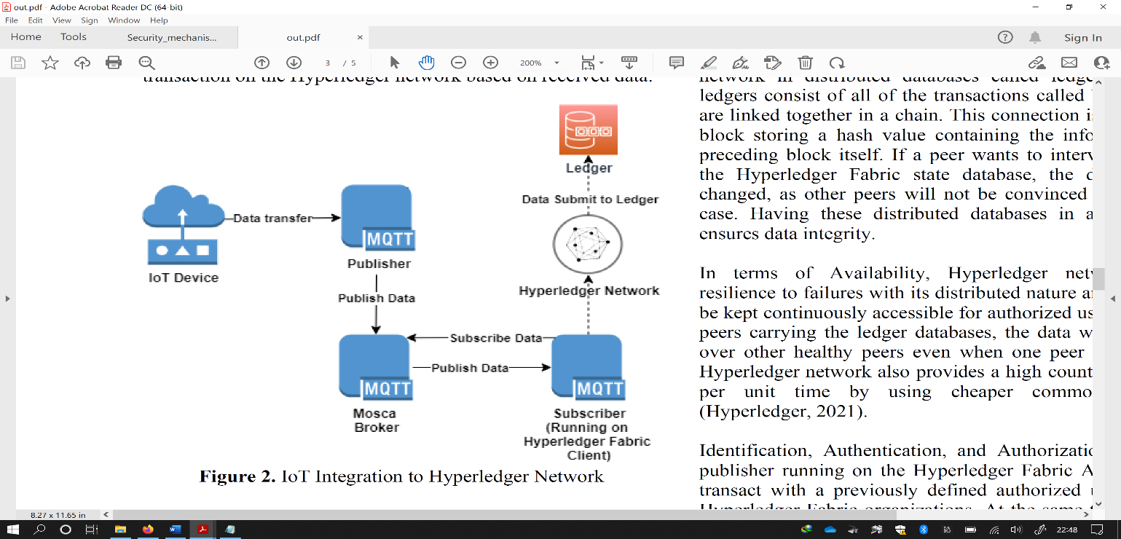

**Fig 7.** IoT Integration to Hyperledger Network [60].

Model made use of blockchain architecture to keep track of data from IoT devices in a public ledger [61]. Because of the decentralized nature of blockchain [62], illegal manipulation of IoT devices is less likely, and blockchain appears to be an effective opportunity for securing and managing IoT device data [63]. There seems to be a trade-off among a hashing algorithm's output size and security. A reduced hash size is right for blockchains associated to IoT contexts in terms of storage memory. These smaller hashes, on the other hand, are simpler to compute and penetrate. To compensate for the lower temporal complexity, a higher difficulty parameter of smaller output sizes hashing algorithms should be used.

Authentication-based techniques can be used to tackle fog layer security challenges; however, in cross-domain connectivity situations under the Software Defined Network (SDN) framework they do not function well. Furthermore, due to the high-security sensitivity of human health data and the peculiar nature of fog nodes, significant problems are faced by the data privacy and system security, and how to support data integrity & signaling and avoid tampering should be properly studied. Likewise, medical IoT peripherals may be untrustworthy or malicious, causing them to file false claims in order to abuse network resources, attain better services, and compromise system security by initiation of cyber-physical attacks; as a result, to ensure the system's security effective security measures should be designed [64].

To guarantee system integrity, a two-layer multidimensional and blockchain-based security scheme, the data layer BottomChain and the control layer TopChain, is explained to resist well to diverse cyber-physical attacks, such as tampering, non-repudiation, and Distributed Denial of Service (DDoS) threats, whereby critical information including human health parameters, the corresponding task processing results & original task information, intra SDN and inter SDN control signaling, and the blacklisting of the edge devices are protected, profiting from the controlling, protected storage size of the blockchains. Additionally, under blockchain-based security mechanism, human data and node activities may be properly traced. Furthermore, single-point failure an inherent problem of SDN is dropped by TopChain.

In the last decade, there have been several cyber-attacks against healthcare services. Unfortunately, earlier solutions do not consider security over data storage and transfers, which has become a critical part in guaranteeing 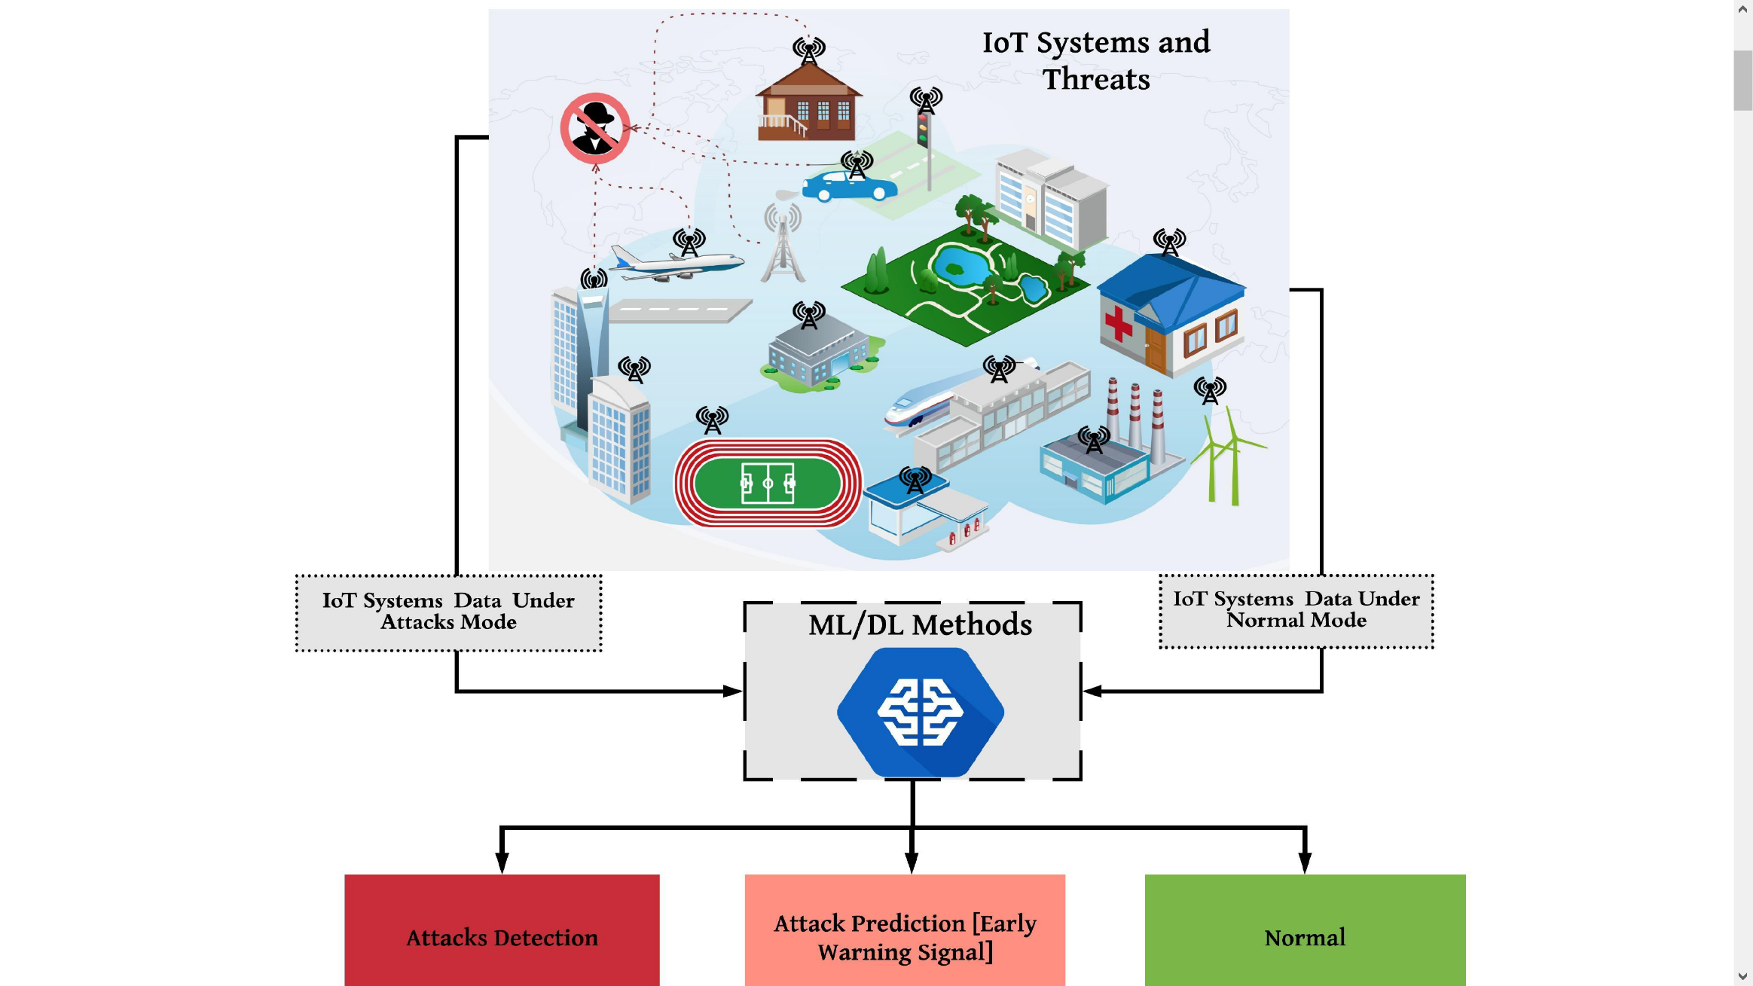privacy and preserving patient medical data in medical. As a result, the information's of smart healthcare is presented in an operational framework for safeguarding, which is one of the major issues faced in current healthcare, such as breaching of patients' sensitive health records for stake and protecting patient's records available in the healthcare organization may cause patient's healthcare unproductive data delivery [65]. One of the problems seen because of unprotected documents is a lag from one service provider to another in the patients' records processing. As a result, the EHR has faced such limitations that can be solved by modern technology like as Blockchain, which has lately been implemented by many governments, public-private partnerships, and private organizations [66].

**Fig 8.** Illustration of the potential role of ML/DL in IoT security.

## B. Artificial Intelligence (AI) based security mechanisms

IoT devices are globally accessible, are made up mostly of limited capabilities, and are connected via lossy networks [67]. As a result, critical changes to current security ideas for networks (wireless and information) to achieve efficient IoT security approaches should be made. It is difficult and inadequate for mega networks to implement current defense measures including application & network security, access control, encryption, and authentication with many linked gadgets, each of which has known weaknesses.

Possessing the capacity to analyze IoT devices, as proved in Fig 6, can effectively give a remedy to new or zero-day assaults. Machine Learning (ML)/ Deep Learning (DL) are strong data analysis methods to discover 'normal' and 'abnormal' behavior in the IoT ecosystem based on how IoT elements and devices communicate with each other. Each part of the IoT system's input data may be gathered and studied to discover normal patterns of interaction, allowing for early detection of malicious conduct. Furthermore, because they can intelligently forecast future unknown assaults by learning from current instances, ML/DL algorithms might be useful in predicting new attacks, which are typically mutations of earlier attacks. As a result, for successful and safe networks, IoT devices must migrate from just supporting connection security between devices to security-based information provided by DL/ML approaches.

1. **ML technique**

ML is a branch of AI that combines a variety of approaches and procedures to give computers and smart devices intelligence. In the network security environment, machine learning techniques such as supervised learning, unsupervised learning, and reinforcement learning have been widely used. It is used to precisely detect and specify the exact data plane security regulations to be enforced. The task at hand is to fine-tune the many aspects of important security protocols to minimize a certain sort of attack, either by tagging network traffic or by setting access policy. Various machine learning approaches may be used to counteract a range of IoT assaults. For instance, neural networks can be employed to identify network intrusion [68] and Denial of Service (DoS) attacks and K-NN can be used in malware detections [69].

1. **Supervised Learning**

The intrinsic relationships of the data might not be accessible in supervised techniques, but the model's outcome is known. Typically, this model's training involves a set of data to "learn" and another set of data to test and assess the resultant model. Matching an attack pattern to a group of previously known assaults is a classic case in the security environment.

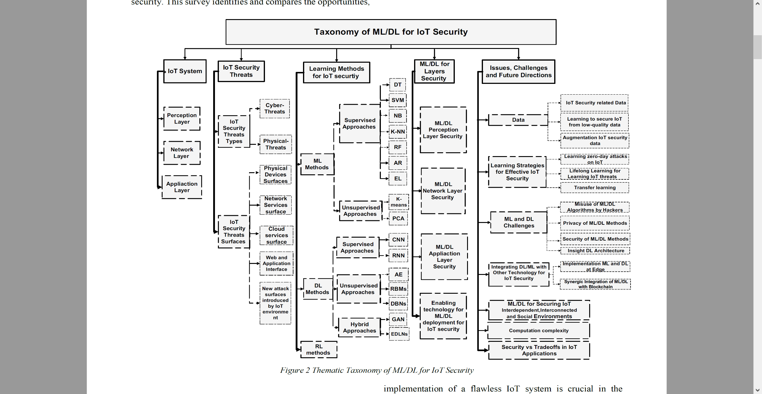

**Fig 9.** Thematic Taxonomy of ML/DL for IoT Security

1. **Unsupervised Learning**

Apart from supervised learning, the model in unsupervised learning is undefined, which means unlabeled data. A relationship between the data and its categorization into categories is done by relevant models.

1. **Reinforcement Learning**

It is concerned with analyzing issues and developing strategies to enhance its model. It has a one-of-a-kind model learning mechanism that incorporates trial and error as well as incentive functions. It keeps track of the output's outcomes and uses the reward to generate a value termed a "value function." The model recognizes the correctness of its choice based on this value and adjusts itself accordingly.

1. **IoT Security based on DL**

To learn data interpretations with multiple degrees of complexity, various processing levels (layers) are integrated by supplied mathematical framework. DL methods have considerably advanced ultramodern applications as compared to traditional ML methods [70]. For generative or discriminative feature manipulation and abstraction for analysis techniques, DL is an ML area that employs numerous non-linear processing layers. Because they may capture hierarchical patterns in deep architecture, DL approaches are sometimes known as hierarchical learning techniques. The operating premise of DL is based on the signal rendering systems of the human brain and neurons. Deep networks can be used for supervised learning (discriminative learning), unsupervised learning (generative learning), or a blend of the two (hybrid DL). Examples of discriminative DL methods are CNNs and recurrent neural networks (RNNs). Deep Autoencoders (AEs), Ensemble of DL Networks (EDLNs), Generative Adversarial Networks (GANs), Deep Belief Networks (DBN), and Restricted Boltzmann Machines (RBMs) falls in hybrid DL approaches.

Although essentially DL is a branch of ML, this paper discusses them in two separate sections to provide the readers with in-depth review, inclusive comparisons, and potential applications of both traditional ML and DL methods for IoT security. The main differences between traditional ML and DL methods have been discussed in previous literature [10, 11]. Similarly, in this paper ML refers to traditional ML methods that require engineered features, while DL methods refer to recent advances in learning methods that utilize several nonlinear processing layers for discriminative or generative feature abstraction and transformation for pattern analysis [12].

Fig 7 shows a thematic taxonomy of ML/DL for IoT security. The remaining parts of the paper adopt the classification presented on the thematic taxonomy. The present survey comprehensively reviews ML/DL algorithms for IoT security that can provide researchers and developers a manual guide to developing an effective and end-to-end security solution based on intelligence.

1. **Related work**

IoT security is a hotly debated research topic that is gaining traction in the scientific field. Many books have been written about this vital topic.

Numerous research publications [71], [72] focuses on analyzing the effectiveness and practicality of operating virtual security equipment on the edge using containers, such as IDS and firewalls, in the context of Network Function Virtualization. Although this lightweight virtualization method proved to be quite efficient, it was difficult to compensate for the resource constrained IoT equipment. Indeed, heavy traffic can lead to significant energy and CPU use, compromising the device's usability. Machine learning algorithms supply an alternate approach to securing IoT networks. [73] proposes a number of methods that make use of SDN architecture and machine learning approaches to enable Network IDS (NIDS). The paper also discusses the difficulties that come with implementing NIDS.

The authors of [74] suggested a system that uses DL to estimate the location of a city bus. For forecasting data rate & locations, neural network based on Long Short-Term Memory (LSTM) have been studied in the proposed approach. Authors in [75] have supplied a method that utilizes block-chain for monitoring scaled IoT systems. The authors of [76] propose a method for securing connections among IoT devices and the MEC. A learning mechanism approach is used to select candidates for service distribution & composition.

To examine the network traffic (moving from gateway to edge devices), Artificial Neural Networks is used [77]. They employed temperature sensors as edge devices and a Raspberry Pi as an IoT gateway in their method. Various data samples are collected from edge devices and stored in a database on the gateway. They then separated the data into training and testing categories. The testing data is being used to confirm the model's accuracy after the neural network has been developed using training data. Although the findings prove an increased degree of security in terms of anomaly detection, the system's capabilities were restricted by the IoT gateway's limited resources, significantly affecting the user experience and the device's longevity. [78] proposes an IDS that runs on top of linked automobiles. For finding threats, the proposed system uses deep belief and decision tree machine learning algorithms.

AI may be used in IoT to find aberrant behaviors depending on factors from both network systems and tangible metrics supplied by IoT devices. Mehta et al. [79] propose an AI-based IDS technique for IoT that detects abnormalities by exploiting the association between a group of sensor data time-series. Furthermore, AI platform is designed to deal with both anomalous-based and knowledge-based IDS by examining signatures and patterns of previously known vulnerabilities and attacks on a continual basis [37]. In this regard, most of the earlier study has concentrated on the identification stage of incidents.

## C. IDS

The security becomes extremely important of those devices which people use as we approach closer to a day where everything people use is connected to the internet. For combating DDoS attacks, in the literature, there are two key systems used. IDS is a preventative mechanism in which the system does not act if an intrusion has occurred, instead an alarm is raised. Intrusion Prevention System (IPS) is a punitive tool in which the system acts in case of an incursion [80]. In IPS, there is a problem with false positives because genuine users might be restricted as well. A full comparison of IDS and IPS systems is shown in Table 7.

TABLE VII

Relative assessment of IPS and IDS approaches [81]

|  |  |
| --- | --- |
| **IPS** | **IDS** |
| Functions of IPS does not need human interaction and are dependent on the rule set. | To perform any action, human intervention is needed. |
| High concern is false alarms. | The false alarm rate has less of an influence on performance than the IPS rate. |
| The system might slow down. | IDS do not affect system performance. |
| Because it analyzes and defends the device, IPS is a regulatory framework. | IDS recognizes the threat and checks the system. |
| False alerts may cause legitimate traffic to be stopped. | The false alarm rate has less of an influence on performance than the IPS rate. |

IDS is also emphasized in this research since in malware categorization major problem is false alarm rate. Punitive step performed against genuine users might sometimes defeat the purpose of developing a detection system. Fig 7 depicts a graphical depiction of the IDS category. Due to varying location of target, it can be classified into Host IDS (HIDS), NIDS, or Hybrid IDS. HIDS is system-specific and is costly since one IDS is needed per host, but can detect an inside intruder with high accuracy, and the scope of the intrusion can be precisely estimated [82]. External intrusion is well found and a NIDS can defend all users, but too much communication packets are travelling in the network to analyze [83]. Because it includes characteristics from both HIDS and NIDS, the hybrid IDS is more versatile and secure [84]. In Active IDS, specific actions are conducted in response to specific warnings, while in Passive IDS, just reports are created, or alarms are raised. Individual monitors are used by centralized IDS to check each host since it does not grow according to demand, resulting in less flexibility. Furthermore, a single point of failure is a risk with centralized IDS. On the other hand, with each observing unit also serving as an evaluation unit, a peer-to-peer (P2P)

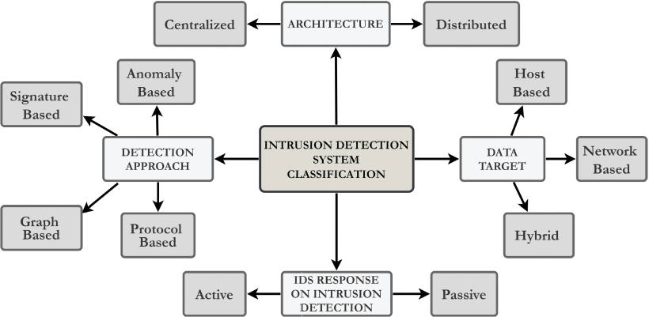

**Fig 10.** How different IDS approaches are classified is illustrated [44].

architecture is the basis of Distributed IDS.

1. **Anomaly Detection Techniques**

Signature-based Detection and Anomaly-based Detection are the two main techniques used for Malware Detection. Because Botnets mutate, and as a result, In case of botnets, bots signature changes, therefore detection approach based on signatures [85] is not amazingly effective. In real-world circumstances to discover varieties of botnet varieties, these methods are ineffective. On the other hand detection algorithms based on anomalies [86], are widely used since they assume Botnet traffic would behave differently from regular traffic.

In the literature, there are several approaches for detecting anomalies. A full comparison of several Anomaly detection strategies is shown in Table 8. The ML based technique is beneficial and widely recognized for a wide variety of malware categorization.

# VI. Conclusion

The progress of IoT has been tremendous, and it has cleared the path for several technological undertakings. IoT security is critical for ongoing technological advancement since investors will only invest in this sector if ultramodern security procedures are implemented. In general, cybersecurity follows the CIA paradigm, which stands for confidentiality, integrity, and availability. Attackers start assaults by exploiting flaws in communication protocols. Improved prevention approaches are necessary for minimizing assaults, as these attacks threaten the reputations of service providers. The assaults affect all three CIA components, which is service providers’ key concern. IoT sensors generate data at many sizes dependent on the application being addressed, ranging between few bytes to multiple Kbytes every second. For example, medical or military data, might be critical at times, due to their ability to bring down victims, major hazards to the cyber world are posed by DDoS attacks. Many computers are needed to launch DDoS attacks for which IoT devices are ideal. Consumers in most circumstances will be unaware that the device has been hacked; for example, limited access is provided by the user interface of baby monitors and smart toys and even after becoming a bot in a botnet army might still be functioning. While IoT devices are growing in the network, there is a need to detect attacks launched by botnets as soon as possible and remove the bots and the infected devices.

The security of the devices is getting critical as we progress towards an era in which everything people use is linked to the internet. In the literature, there are two primary techniques for avoiding DDoS attacks: IDS and IPS. The IDS is reviewed, and multiple intrusion detection models have been explored. Furthermore, we addressed IDS categorization, various anomaly detection approaches, multiple IDS methods depending on datasets, various ML, and DL procedures for pre-processing data and detecting malware. Finally, after examining several intrusion detections approaches and future ambitions, a larger viewpoint was envisioned.

|  |  |  |  |  |
| --- | --- | --- | --- | --- |
| **Paper** | **Method** | **Cases** | **Methodology** | **Advantage (+), Disadvantage (-)** |
| Choudhary et al. [87] | Protocol based model | • Communication protocol  • Application protocol | • The protocol-based architecture employs several levels of surveillance protocols.  • Discrepancies linked with a protocol are found using computing methods. | * For a certain sort of assault, recognition efficiency is excellent. * Because it is only good for some sorts of assaults, it is useless against others. |
| Kumar et al. [88] | Model based on rules | Rules based on:  • Behavior  • Fuzzy  • Association | • Patterns are formed from data flow patterns in a rule-based paradigm.  • When a rule is breached, it is referred to as anomalous behavior. | * The model is straightforward. * For rule generation, more traffic monitoring is necessary. * A high rate of false positives |
| Kim et al. [89] | Model based on payload | Models:  • N-gram  • Grained | • Features of a typical packet payload are analyzed, and any divergence is regarded as abnormal. | * For known assaults, the model performs admirably. * Because of the computational overhead, the handling time is greater. * For fresh attacks, the accuracy is lower. |
| Kalkan et al. [90] | Model based on statistics | • Multivariate  • Univariate  • Markov process  • Time series | • Mathematical computations are used in the statistical model method.  • The user's earlier data is used to develop a model for usual behavior. | * The model is straightforward. * The correctness of the model is influenced using statistical or mathematical modelling. |
| Hai et al. [91] | Model based on ML | • Neural networks  • Outlier detection  • Clustering  • Classification  • Genetic algorithms | • Training and testing are the two steps of machine learning models.  • Learning is of two types: supervised & unsupervised. | * Can quickly recognize patterns. * A wide range of applications is possible. * Appropriate for online datasets. * Can continue to improve. * Lengthy periods of training are necessary. * For better results, a larger data collection is needed. |

TABLE VIII

A comparison of anomaly classification methods

# References

|  |  |
| --- | --- |
| [1] | K. Ashton, "That ‘internet of things’ thing," *RFID journal,* vol. 22, no. 7, pp. 97-114, 2009. |
| [2] | Wikipedia, "Enigma machine," 2022. [Online]. Available: https://en.wikipedia.org/wiki/Enigma_machine. |
| [3] | "IEEE Standard for an Architectural Framework for the Internet of Things (IoT)," IEEE Std, 2020. |
| [4] | "An Overview of Enabling Technologies for the Internet of Things," Internet of Things A to Z: Technologies and Applications , IEEE, 2018. |
| [5] | K. K. Vaigandla, R. K. Karne and A. S. Rao, "A Study on IoT Technologies, Standards and Protocols," *IBMRD's Journal of Management & Research,* vol. 10, no. 2, pp. 7-14, 2021. |
| [6] | T. Salman and R. Jain, "A Survey of Protocols and Standards for Internet of Things," *Advanced Computing and Communications,* vol. 1, no. 1, 2017. |
| [7] | G. Mavridis, "Security mechanisms for Internet of Things (IoT)," University of East London, Greece, Piraeus, 2017. |
| [8] | L. S. Vailshery, "IoT and non-IoT connections worldwide 2010-2025," 2021. [Online]. Available: https://www.statista.com/statistics/1101442/iot-number-of-connected-devices-worldwide/. |
| [9] | T. Gebremichael, L. P. I. Ledwaba, M. H. Eldefrawy and G. P. Hancke, "Security and Privacy in the Industrial Internet of Things: Current Standards and Future Challenges," *IEEE Access,* vol. 8, pp. 152351-152366, 2020. |
| [10] | A. H. Imam and M. A. Azer, "Internet of Things security framework," *13th International Computer Engineering Conference (ICENCO),* pp. 378-382, 2017 . |
| [11] | D. Bassole, K. K. Kabore, Y. Traore, O. Sie and H. B. Sta, "Design and implementation of secure communication protocols for Internet of Things systems," *IEEE International Smart Cities Conference (ISC2),* pp. 112-117, 2019 . |
| [12] | S. Rizvi, A. Kurtz, J. Pfeffer and M. Rizvi, "Securing the Internet of Things (IoT): A Security Taxonomy for IoT," *17th IEEE International Conference On Trust, Security And Privacy In Computing And Communications/ 12th IEEE International Conference On Big Data Science And Engineering (TrustCom/BigDataSE),* pp. 163-168, 2018 . |
| [13] | B. Nathani and R. Vijayvergia, "The Internet of Intelligent things: An overview," *2017 International Conference on Intelligent Communication and Computational Techniques (ICCT),* 2017. |
| [14] | J. P. Nzabahimana, "Analysis of security and privacy challenges in Internet of Things," *2018 IEEE 9th International Conference on Dependable Systems, Services and Technologies (DESSERT),* 2018. |
| [15] | A. Banerjee, K. K. Venkatasubramanian, T. Mukherjee and S. K. S. Gupta, "Ensuring safety, security, and sustainability of mission-critical cyber–physical systems," *Proceedings of the IEEE,* vol. 100, pp. 283-299, 2012. |
| [16] | K. Wan and V. Alagar, "Context-aware security solutions for cyber-physical systems," *Mobile Networks and Applications,* vol. 19, pp. 212-226, 2014. |
| [17] | R. AlTawy and A. M. Youssef, "Security tradeoffs in cyber physical systems: A case study survey on implantable medical devices," *IEEE Access,* vol. 4, pp. 959-979, 2016. |
| [18] | M. Abomhara, "Cyber security and the internet of things: vulnerabilities, threats, intruders and attacks," *Journal of Cyber Security and Mobility,* vol. 4, pp. 65-88, 2015. |
| [19] | R. Roman, J. Zhou and J. Lopez, "On the features and challenges of security and privacy in distributed internet of things," *Computer Networks,* vol. 57, pp. 2266-2279, 2013. |
| [20] | S. Babar, P. Mahalle, A. Stango, N. Prasad and R. Prasad, "Proposed security model and threat taxonomy for the Internet of Things (IoT)," *International Conference on Network Security and Applications,* pp. 420-429, 2010. |
| [21] | J. Lopez, R. Roman and C. Alcaraz, "Analysis of security threats, requirements, technologies and standards in wireless sensor networks," *Foundations of Security Analysis and Design,* vol. Springer, pp. 289-338, 2009. |
| [22] | C. Camara, P. Peris-Lopez and J. E. Tapiador, "Security and privacy issues in implantable medical devices: A comprehensive survey," *Journal of biomedical informatics,* vol. 55, pp. 272-289, 2015. |
| [23] | M. R. Rieback, B. Crispo and A. S. Tanenbaum, "Is your cat infected with a computer virus?," *Pervasive Computing and Communications,* 2006. |
| [24] | B. Schneier, Secrets and lies: digital security in a networked world, John Wiley & Sons, 2011. |
| [25] | B. Jung, I. Han and S. Lee, "Security threats to Internet: a Korean multi-industry investigation," *Information & Management,* vol. 38, pp. 487-498, 2001. |
| [26] | T. Bose, S. Bandyopadhyay, A. Ukil, A. Bhattacharyya and A. Pal, "Why not keep your personal data secure yet private in IoT?: Our lightweight approach," *Intelligent Sensors, Sensor Networks and Information Processing (ISSNIP), 2015 IEEE Tenth International Conference,* pp. 1-6, 2015. |
| [27] | X. Yao, Z. Chen and Y. Tian, "A lightweight attribute-based encryption scheme for the Internet of Things," *Future Generation Computer Systems,* vol. 49, pp. 104-112, 2015. |
| [28] | F. A. Alaba, M. Othman, I. A. T. Hashem and F. Alotaibi, "Internet of Things security: A survey," *Journal of Network and Computer Applications,* vol. 88, pp. 10-28, 2017. |
| [29] | D. T. M. R. Abdmeziem, "An end-to-end secure key management protocol for e-health applications," *Computers & Electrical Engineering,* vol. 44, pp. 184-197, 2015. |
| [30] | S. Sicari, A. Rizzardi, L. A. Grieco and A. Coen-Porisini, "Security, privacy and trust in Internet of Things: The road ahead," *Computer networks,* vol. 76, pp. 146-164, 2015. |
| [31] | S. R. M. e. al., "SEA: a secure and efficient authentication and authorization architecture for IoT-based healthcare using smart gateways," *Procedia Computer Science,* vol. 52, pp. 452-459, 2015. |
| [32] | S. F. Wamba, A. Anand and L. Carter, "A literature review of RFID-enabled healthcare applications and issues," *International Journal of Information Management,* vol. 33, pp. 875-891, 2013. |
| [33] | K. Malasri and L. Wang, "Securing wireless implantable devices for healthcare: Ideas and challenges," *IEEE Communications Magazine,* vol. 47, 2009. |
| [34] | I. Y. e. al., "The rise of ransomware and emerging security challenges in the Internet of Things," *Computer Networks,* vol. 129, pp. 444-458, 2017. |
| [35] | J. Zhou, Z. Cao, X. Dong and A. V. Vasilakos, "Security and privacy for cloud-based IoT: Challenges," *IEEE Communications Magazine,* vol. 55, pp. 26-33, 2017. |
| [36] | C. Bekara, "Security issues and challenges for the IoT-based smart grid," *Procedia Computer Science,* vol. 34, pp. 532-537, 2014. |
| [37] | B. B. Zarpelao, R. S. Miani, C. T. Kawakani and S. C. d. Alvarenga, "A survey of intrusion detection in Internet of Things," *J. Netw. Comput. Appl,* vol. 84, pp. 25-37, 2017. |
| [38] | E. Bertino and N. Islam, "Botnets and internet of things security," *Computer,* vol. 50, pp. 76-79, 2017. |
| [39] | C. Kolias, G. Kambourakis, A. Stavrou and J. Voas, "DDoS in the IoT: Mirai and other botnets," *Computer,* vol. 50, pp. 80-84, 2017. |
| [40] | M. Nawir, A. Amir, N. Yaakob and O. B. Lynn, "Internet of Things (IoT): Taxonomy of security attacks," *Electronic Design (ICED),* pp. 321-326, 2016. |
| [41] | L. Atzori, A. Iera and G. Morabito, "The internet of things: A survey," *Computer networks,* vol. 54, pp. 2787-2805, 2010. |
| [42] | J. Gubbi, R. Buyya, S. Marusic and M. Palaniswami, "Internet of Things (IoT): A vision, architectural elements, and future directions," *Future generation computer systems,* vol. 29, pp. 1645-1660, 2013. |
| [43] | Q. Jing, A. V. Vasilakos, J. Wan, J. Lu and D. Qiu, "Security of the Internet of Things: perspectives and challenges," *Wireless Networks,* vol. 20, pp. 2481-2501, 2014. |
| [44] | C. Karlof, N. Sastry and D. Wagner, "TinySec: a link layer security architecture for wireless sensor networks," *Proceedings of the 2nd international conference on Embedded networked sensor systems,* pp. 162-175, 2004. |
| [45] | C. Perera, A. Zaslavsky, P. Christen and D. Georgakopoulos, "Context aware computing for the internet of things: A survey," *IEEE communications surveys & tutorials,* vol. 16, pp. 414-454, 2014. |
| [46] | I. F. Akyildiz, W. Su, Y. Sankarasubramaniam and E. Cayirci, "A survey on sensor networks," *IEEE Communications magazine,* vol. 40, pp. 102-114, 2002. |
| [47] | Z. Cao, J. Hu, Z. Chen, M. Xu and X. Zhou, "Feedback: Towards Dynamic Behavior and Secure Routing for Wireless Sensor Networks," *Advanced Information Networking and Applications, 2006. AINA 2006. 20th International Conference,* vol. 2, pp. 160-164, 2006. |
| [48] | C. Modi, D. Patel, B. Borisaniya, H. Patel, A. Patel and M. Rajarajan, "A survey of intrusion detection techniques in cloud," *Journal of Network and Computer Applications,* vol. 36, pp. 42-57, 2013. |
| [49] | Y. Liu, C. Cheng, T. Gu, T. Jiang and X. Li, "A lightweight authenticated communication scheme for smart grid," *IEEE Sensors Journal,* vol. 16, pp. 836-842, 2016. |
| [50] | Ş. Bahtiyar and M. U. Çağlayan, "Extracting trust information from security system of a service," *Journal of Network and Computer Applications,* vol. 35, pp. 480-490, 2012. |
| [51] | S. R. Islam, D. Kwak, M. H. Kabir, M. Hossain and K.-S. Kwak, "The internet of things for health care: a comprehensive survey," *IEEE Access,* vol. 3, pp. 678-708, 2015. |
| [52] | A. A. e. al., "Secure and dependable software defined networks," *Journal of Network and Computer Applications,* vol. 61, pp. 199-221, 2016. |
| [53] | N. E. Ioini and C. Pahl, "A Review of Distributed Ledger Technologies," *On the Move to Meaningful Internet Systems. OTM 2018 Conferences Confederated International ,* vol. 11230 , pp. 277-288, 2018. |
| [54] | S. Sakho, Z. Jianbiao, F. Essaf and K. Badiss, "Improving Banking Transactions Using Blockchain Technology," *IEEE 5th International Conference on Computer and Communications (ICCC),* pp. 1258-1263, 2019 . |
| [55] | N. Rožman, R. Vrabič, M. Corn, T. Požrl and J. Diaci, "Distributed logistics platform based on Blockchain and IoT," *Procedia CIRP,* Vols. 81,, pp. 826-831, 2019,. |
| [56] | T. Bocek, B. B. Rodrigues, T. Strasser and B. Stiller, "Blockchains everywhere - a use-case of blockchains in the pharma supply-chain," *IFIP/IEEE Symposium on Integrated Network and Service Management (IM),* pp. 772-777, 2017 . |
| [57] | K. Košťál, P. Helebrandt, M. Belluš, M. Ries and I. Kotuliak, "Management and Monitoring of IoT Devices Using Blockchain," *Sensors for Information Technology, Electronics and Mobile Communication,* vol. 19(4), p. 856, 2019. |
| [58] | S. Huh, S. Cho and S. Kim, "Managing IoT devices using blockchain platform," *19th International Conference on Advanced Communication Technology (ICACT). Global IT Research Institute - GiRI,* pp. 464-467, 2017 . |
| [59] | P. Gupta, V. Dedeoglu, S. S. Kanhere and R. Jurdak, "Towards a blockchain powered IoT data marketplace," *International Conference on COMmunication Systems & NETworkS (COMSNETS),* pp. 366-368, 2021 . |
| [60] | K. O. Toka, Y. Dikilitaş, T. Oktay and A. Sayar, "Securing Iot with Blockchain," *The International Archives of Photogrammetry, Remote Sensing and Spatial Information Sciences,* vol. 46, pp. 529--532, 2021. |
| [61] | A. Alrehaili and A. Mir, "POSTER: Blockchain-based Key Management Protocol for Resource-Constrained IoT Devices," *First International Conference of Smart Systems and Emerging Technologies (SMARTTECH),* pp. 253-254, 2020 . |
| [62] | M. Singh, A. Singh and S. Kim, "Blockchain: A Game Changer For Securing IoT Data," *IEEE 4th World Forum on Internet of Things (WF-IoT),* 2018 . |
| [63] | K. Gagneja and R. Kiefer, "Security Protocol for Internet of Things (IoT): Blockchain-based Implementation and Analysis," *Sixth International Conference on Mobile And Secure Services (MobiSecServ),* 2020 . |
| [64] | J. Ren, J. Li, H. Liu and T. Qin, "Task offloading strategy with emergency handling and blockchain security in SDN-empowered and fog-assisted healthcare IoT," *Tsinghua Science and Technology,* vol. 4, no. 27, pp. 760-776, 2022. |
| [65] | A.Yogeshwar and S. Kamalakkanna, "Healthcare Domain in IoT with Blockchain Based Security- A Researcher’s Perspectives," *Fifth International Conference on Intelligent Computing and Control Systems (ICICCS 2021),* 2021. |
| [66] | N. Kshetri, "Blockchain and electronic healthcare records [cybertrust] Computer," vol. 51, no. 12 , p. 59–63, 2018. |
| [67] | A. M. d. S. Cardoso, R. F. Lopes, A. S. Teles and F. B. V. Magalhães, "Poster Abstract: Real-Time DDoS Detection Based on Complex Event Processing for IoT," *IEEE/ACM Third International Conference on Internet-of-Things Design and Implementation (IoTDI),* pp. 273-274, 2018. |
| [68] | S. Latif, Z. Idrees, Z. Zou and J. Ahmad, "DRaNN: A Deep Random Neural Network Model for Intrusion Detection in Industrial IoT," *International Conference on UK-China Emerging Technologies (UCET),* pp. 1-4, 2020 . |
| [69] | Z. H. Abdaljabar, O. N. Ucan and K. M. A. Alheeti, "An Intrusion Detection System for IoT Using KNN and Decision-Tree Based Classification," *International Conference of Modern Trends in Information and Communication Technology Industry (MTICTI),* pp. 1-5, 2021 . |
| [70] | T. J. Sejnowski, The Rise of Machine Learning, MIT Press, 2018. |
| [71] | A. R. Boudi, I. Farris, M. Bagaa and T. Taleb, "Assessing Lightweight Virtualization for Security-as-a-Service at the Network Edge," *IEICE Transactions on Communications,* vol. E102, pp. 970-977, 2019. |
| [72] | R. Morabito, V. Cozzolino, A. Y. Ding, N. Beijar and J. Ott, "Consolidate IoT edge computing with lightweight virtualization," *IEEE Network,* vol. 32, pp. 102-111, 2018. |
| [73] | N. Sultana, N. Chilamkurti, W. Peng and R. Alhadad, "Survey on SDN based network intrusion detection system using machine learning approaches," *Peer-to-Peer Netw. Appl.,* vol. 12, pp. 493-501, 2019. |
| [74] | S. Zafar, S. Jangsher, O. Bouachir, M. Aloqaily and J. B. Othman, "QoS enhancement with deep learning-based interference prediction in mobile IoT," *Comput. Commun.,* vol. 148, pp. 86-97, 2019. |
| [75] | L. Tseng, L.Wong, S. Otoum, M. Aloqaily and J. B. Othman, "Blockchain for managing heterogeneous Internet of Things: A perspective architecture," *IEEE Netw.,* vol. 34, pp. 16-23, 2020. |
| [76] | I. A. Ridhawi, S. Otoum, M. Aloqaily, Y. Jararweh and T. Baker, "Providing secure and reliable communication for next generation networks in smart cities," *Sustain. Cities Soc.,* vol. 56, 2020. |
| [77] | X. Wang, Y. Han, V. C. M. Leung, D. Niyato, X. Yan and X. Chen, "Convergence of edge computing and deep learning: A comprehensive survey," *IEEE Commun. Surveys Tuts,* 2020. |
| [78] | M. Aloqaily, S. Otoum, I. A. Ridhawi and Y. Jararweh, "An intrusion detection system for connected vehicles in smart cities," *Ad Hoc Netw,* vol. 90, 2019. |
| [79] | A. M. Zarca, J. B. Bernabe, R. Trapero, D. Rivera, J. Villalobos, A. Skarmeta, S. Bianchi, A. Zafeiropoulos and P. Gouvas, "Security management architecture for NFV/SDN-aware IoT systems," *IEEE Internet Things,* vol. 6, pp. 8005-8020, 2019. |
| [80] | C. V. Martínez and B. Vogel-Heuser, "Towards industrial intrusion prevention systems: A concept and implementation for reactive protection," *Appl. Sci.,* vol. 8, pp. 1-29, 2018. |
| [81] | N. Mishra and S. Pandya, "Internet of Things Applications, Security Challenges, Attacks, Intrusion Detection, and Future Visions: A Systematic Review," *IEEE Access,* vol. 9, pp. 59353-59377, 2021. |
| [82] | T. R. Glass-Vanderlan, M. D. Iannacone, M. S. Vincent, Q. Chen and R. A. Bridges, "A survey of intrusion detection systems leveraging host data," *ACM Comput. Surv.,* vol. 52, p. 128, 2018. |
| [83] | R. Panigrahi, S. Borah, A. K. Bhoi and P. K. Mallick, "Intrusion detection systems (IDS)-An overview with a generalized framework," *Adv. Intell. Syst. Comput.,* vol. 1040, pp. 107-117, 2020. |
| [84] | A. N. Cahyo, A. K. Sari and M. Riasetiawan, "Comparison of hybrid intrusion detection system," *Proc. 12th Int. Conf. Inf. Technol. Electr. Eng. (ICITEE),* pp. 92-97, 2020. |
| [85] | J. Ghasemi, J. Esmaily and R. Moradinezhad, "Intrusion detection system using an optimized kernel extreme learning machine and efficient features," *Sadhana-Acad. Eng. Sci.,* vol. 45, 2020. |
| [86] | E. Herrera-Viedma and H. Fujita, "Multilayer framework for botnet detection using machine learning algorithms," *IEEE Access,* vol. 9, pp. 48753-48768, 2021. |
| [87] | S. Choudhary and N. Kesswani, "A survey: Intrusion detection techniques for Internet of Things," *Int. J. Inf. Secur. Privacy,* vol. 13, pp. 86-105, 2019. |
| [88] | V. Kumar, D. Sinha, A. K. Das, S. C. Pandey and R. T. Goswami, "An integrated rule based intrusion detection system: Analysis on UNSW-NB15 data set and the real time online dataset," *Cluster Comput.,* vol. 23, pp. 1397-1418, 2020. |
| [89] | A. Kim, M. Park and D. H. Lee, "AI-IDS: Application of deep learning to real-time Web intrusion detection," *IEEE Access,* vol. 8, pp. 70245-70261, 2020. |
| [90] | K. Kalkan, L. Altay, G. Gür and F. Alagöz, "JESS: Joint entropy-based DDoS defense scheme in SDN," *IEEE J. Sel. Areas Commun.,* vol. 36, pp. 2358-2372, 2018. |
| [91] | T. H. Hai, L. H. Hoang and E.-N. Huh, "Network anomaly detection based on late fusion of several machine learning algorithms," *Int. J. Comput. Netw. Commun.,* vol. 12, pp. 117-131, 2020. |

1.